Chapter 14 - Learning 1 - Regression

Introduction, Concepts, and Nomenclature

14.1 - Introduction
Ultimately, the most exciting part about machine learning is giving our algorithms the means to find solutions on our behalf. This has two obvious and significant advantages. First, we do not need to specify the rules and parameters ourselves. Coming up with the right set of these is tedious to do by hand, and we would have to repeat the process every time the input data changes slightly. Second, given the space of possible combinations of parameters and rules, it becomes not only tedious but, in most cases, practically impossible to have humans find and implement them. The more complex the data, the more complex the rules. Imagine you had to devise a set of rules that, when applied to raw pixels of an image, predicted whether that picture features a dog. The number of subtle little rules that we would have come up with, for each possible type of dog, for each position, size, angle, and occlusion of the dog in the image, for each pixel, is simply too vast. It would take a human beyond the end of time to iterate and test all these rules. And that is just for dogs. Now imagine doing that again for cats, bunnies, airplanes, staplers, etc.

14.2 - Why this is probably the most important chapter in this course
I would argue that this chapter and the next one on classification are the key chapters of this course. Not only will you learn how to train a machine learning model to perform regression and classification, but it will also introduce you to some key features, concepts, and ideas in machine learning. We will discuss normalization, loss, error, r-squares, regularization, ordinary least squares, conventional, batch, and stochastic descent, learning rates, stopping criteria, hyperparameter tuning, overfitting, accuracy, precision, recall, F1-scores, receiver-operator-characteristics curves, to name but a few. As such, this chapter (and the next) are dense and long. And there are plenty of notebooks and playgrounds to help your master, understand, and form an intuition of these core machine learning concepts. But before we dive in, it helps to reformulate the overarching framework of what we are trying to accomplish once more. We have done so in earlier chapters, highlighting the different algorithmic objectives, different flavors of algorithms, data types, and learning methodologies. But what all of them have in coming, from a machine learning perspective, is the following. Our model seeks to find a mapping function (a parameterized machine learning model) between some available input data and an output of some interest. We want this mapping to be as informative as possible, either guided by ground truth examples (in supervised learning) or by mathematical regularities in the input data (in unsupervised learning). We set ourselves criteria to tell us about the quality or success of this mapping, given a set of parameters currently defining that mapping. Should the quality of our mapping fall short of our criteria, we will update the parameters as long as such updates yield significant improvements in the quality of our mapping function. When you feel overwhelmed with the details, try to understand what piece of the process we are currently working on. Are we defining what the mapping can look like? Are we defining what constitutes a metric of algorithmic accuracy or success? Or are we mitigating issues that make improving the model's parameters problematic? This overview-focused thinking will hopefully allow you to see similarities across many different algorithms and approaches.


Figure 14.1 - Infinite regression as illustrated by the Droste effect. Shown here in its original packaging, the Dutch company Droste marketed a cacao powder tin, which on it has an illustration of a woman in traditional clothing carrying a tray with the very same tin of Droste cacao powder, which also features an illustration of a woman in traditional clothing, etc. You get the point.

14.3 – Getting started with linear regression
Like most texts on machine learning, we will start with linear regression. Why linear regression? For several reasons. First, it is a relatively easy algorithmic objective. There are no non-linearities or complex activation functions and transformations. And the resulting models are easy to understand. They make intuitive sense if your data 1) makes some intuitive sense and 2) contains a mapping of inputs onto an output that is at least to some degree linear. But there is a second reason for starting with linear regression. Depending on your background, you may have already been introduced to linear regression from a statistics point of view, with its unique way of solving the regression problem. Alternatively, your background might be more mathematical and algebraic, in which case you will have been introduced to linear equations and systems and perhaps practiced solving these systems. This background should be useful when introduced to the machine learning approach for building linear regression models. Given this book's target audience, we will work through all three approaches.

Figure 14.2 - For those not using a password manager (you should), you probably have different variations of the same password for different websites and services. In machine learning, we often have many different words for similar, if not identical concepts, due to the field being an amalgamation of different older fields, like statistics, algebra, and engineering.

14.4 - Nomenclature - Weights, parameters, and hyperparameters
Given that we will discuss linear regression from the perspective of three different fields, it is inevitable that we will have nomenclature confusion. Let us take a few moments to go over the different ways certain key concepts can be and are referred to. Although we have tried our utmost not to further confuse the reader by being equally inconsistent as many different texts on the topic can be, we can't make any strong promises we will have succeeded. A common source of confusion can arise from the interchangeable use of the word 'parameter' and 'weight'. Parameters are perhaps primarily associated with models or functions, whereas 'weight' is perhaps more often used when describing neural networks. But neural networks are themselves models and implement functions or mappings between inputs and outputs. So, both terms are appropriate descriptors. We could argue, however, that the word parameter is perhaps a more general term than weight. A linear regression model will have weights representing our function's slope and intercepts. Still, in training such a model, we typically specify learning rates and convergence criteria. These parameters are not part of the model and are no longer needed after training has been completed, so calling them weights seems inaccurate. It is common to refer to them as hyperparameters. It is a good strategy to train your model using different values for your hyperparameters and iterate over possible settings in some systematic way. This is called hyperparameter search or tuning. It can be an expensive process, in both time and needed computational resources, as we need to train our algorithm on each combination of different hyperparameters. For more complex models, it is worth the effort. Not only do we regularly find a better and more stable model in this way, but it also makes us more clearly understand some of the interplays between model and data, especially when this goes awry. We will discuss hyperparameter search in Chapter 15 and beyond.

14.4 - Nomenclature - Variables, regressors, and predictors
In a typical machine learning problem, our input data is a 2D array of data. Each row is a data point, and each column is an input variable. Note that input variables are sometimes called predictors or regressors. If you have ten different input variables (predictors or regressors), we consider your input data to be 10-dimensional, where each variable represents one dimension. Each dimension is associated with an axis.
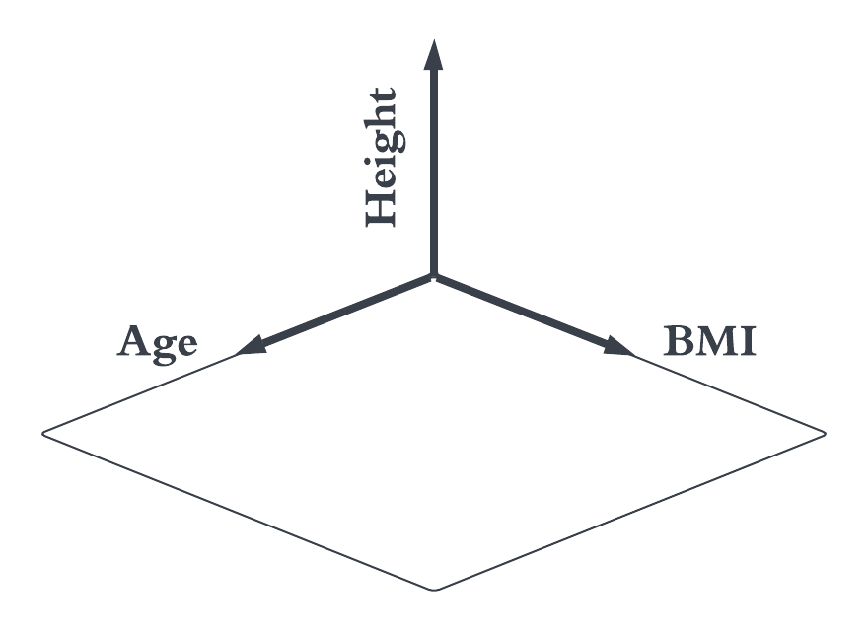
Figure 14.3 - Euclidean geometry has three orthogonal and independent axes. Their direction is arbitrary but being orthogonal is key. Without it, the relationships we take for granted in Euclidean geometry fail. We imagine our data to live in similar N-dimensional spaces, where the dimensions/axes represent different variables, like age, sex, BMI, etc. However, these axes are not likely to be completely orthogonal, as our variables are likely not all completely statistically independent. Things in the world correlate. Two pixels next to each other in an image are usually highly correlated. Gender correlates with income and education (it shouldn't, but it does). Somebody's body temperature is correlated with time, as it increases and decreases as a function of the time of day and circadian rhythm. This doesn't mean there is always a necessary causal link between two variables, but correlations can make it hard for models to learn.

Thinking of dimensions in our data as axes along which your input data can vary is in line with the geometric perspective I subscribe to. If your data has three dimensions (e.g., age, height, and BMI of a patient), you can plot each patient as a point in this 3D space. As we have discussed before, our axes might not be orthogonal. In the Euclidean geometry of space, there are three orthogonal directions (x, y, and z). They are orthogonal in that you can move along a direction (or dimension or axis) without any change to the two other directions (dimensions, axes). But consider age, height, and BMI. Are they orthogonal and independent? I would argue that they are not, especially when our patients come from all age groups, from the very young to the very old. As we grow older, we also grow up and grow bigger. Therefore, moving along the age direction will also move us in the height and BMI direction. Understanding these interdependencies between variables that are likely present in your input data is key to building stable machine learning models. Exploration of your data before training your models will significantly help with that.

14.5 - Data exploration - Medical Expense Dataset
We will use a data set that links total medical costs with several demographics: their age, the US region in which they reside, whether they smoke, their BMI, their sex assigned at birth, and the number of children conceived (if sex is female). The data is hosted on Kaggle for those interested in its history and collection methods: tinyurl.com/y45v3dsn. Whatever kind of data you might be using, it is always a good idea to plot a few summary statistics, distributions, and individual input data points. There will always be surprises. There will always be a need for some decision-making because of outliers, biased classes, missing values, etc. As we rely more and more on specialized toolboxes, we lose that feel for our data. Algorithms today are more and more black boxes, hiding the inner workings and our understanding behind layers of complexity. At the very least, we should know a thing or two about the data we provide to these models as input. The data we use here is already a good example of what you might learn by plotting various views of the data. The figure below plots total medical expense (in dollars x1000) as a function of age, which each dot representing a single data point. Already a few interesting effects can be observed. Across the board, it seems that medical expenses increase as a function of age, the effect we are hoping to predict. However, the data appears to be broken into three distinct bands, shifted relative to each other, see Figure 14.4. How do we explain that?

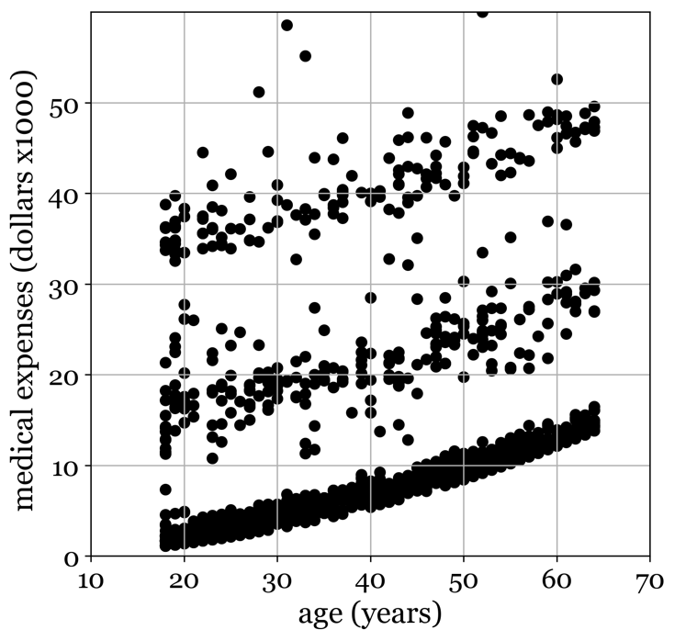
Figure 14.4 - Medical expenses dataset, plotting medical expenses as a function of age. Notice the distinct bands. How would you begin to explain them?

Could the shift in expenses be the result of tobacco use? When we color code the data points based on whether an individual self-identifies as a smoker, we see that smokers appear shifted up along the y-axis, relative to their non-smokers, see Figure 14.5A. The relationship between age and medical expenses is about the same for smokers and non-smokers, with the difference being that smokers have a higher baseline level of expenses, independent of age. This explains the differences between the upper and lower band of data well, as smokers appear almost exclusively in the upper band and non-smokers in the lower band. But what about the middle band? Perhaps we can explain other differences in medical expenses by considering sex. Figure 14.B plots the same data but is now color-coded as a function of sex. Before doing so, we should acknowledge that both being a smoker and your sex cannot explain the existence of the three bands alone, as both variables only have two levels. A moot point, it turns out, as sex does not seem to influence where your medical expenses end up on average. Specifically, data points don't cluster into bands based on sex. Used to color code the data points in Figure 14.5c, the final categorical variable is region, which has four levels. Like sex, this does not seem to explain the observed band-like structure. Thus, of these three perspectives of looking at the data, isolating the categorical variables, only smoking appears to increase the patient's medical expenses by a fixed amount, independent of the effect of age. Although, again, it cannot fully account for the pronounced three-band structure we observe.

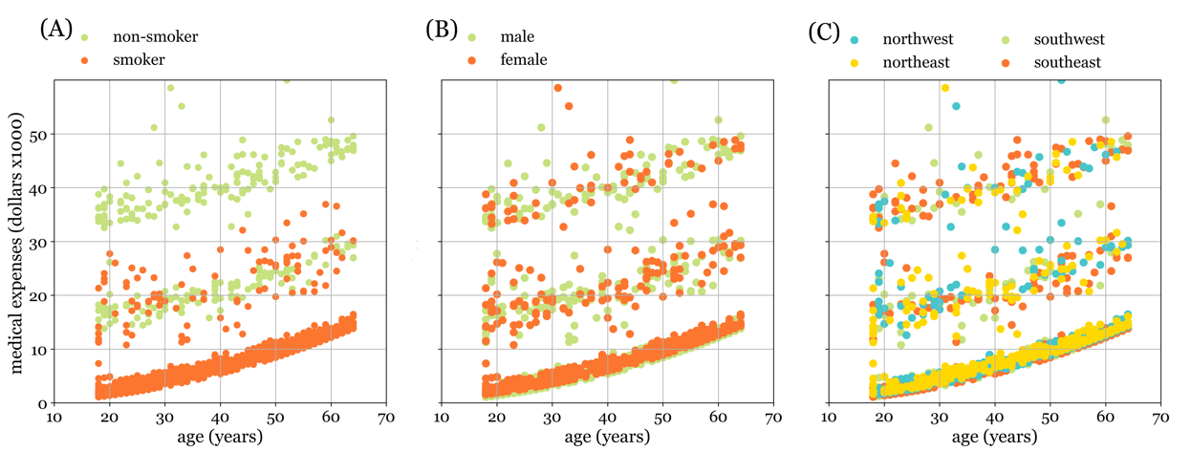
Figure 14.5 - Medical expense dataset, plotting medical expenses as a function of age, with individual data points labeled according to their label. (A) Data points indicate whether patients indicated they smoked (red points) or not (green points). (B) Data points indicate the sex assigned at birth (red for males, green for females). (C) Data points indicate the region of residency of the patient, aggregated into four US zones: North-East (yellow), South-East (red), North-West (lime), and South-West (cyan).

Perhaps we can explain the band-like structure with the two other numerical variables: the person's BMI and the number of children. From first principles, this is unlikely. The band-like structure seems to indicate a categorical shift. If there were an effect of BMI or the number of children, we would expect a more gradient-like color coding. However, there appears to be somewhat of a gradient indicating the effect of increased BMI on medical expenses, but if it is there, it is small, see Figure 14.6A. In contrast, the number of children (Figure 14.6B) seems not to affect the amount of medical expenses accrued. However, on closer inspection of the lowest band of data, we see a pronounced effect of the number of children on the total medical expenses of the birth parent (Figure 14.7B). These observations together provide a strong argument for a close visual inspection of your data. Without it, you might miss such subtle but profound effects.
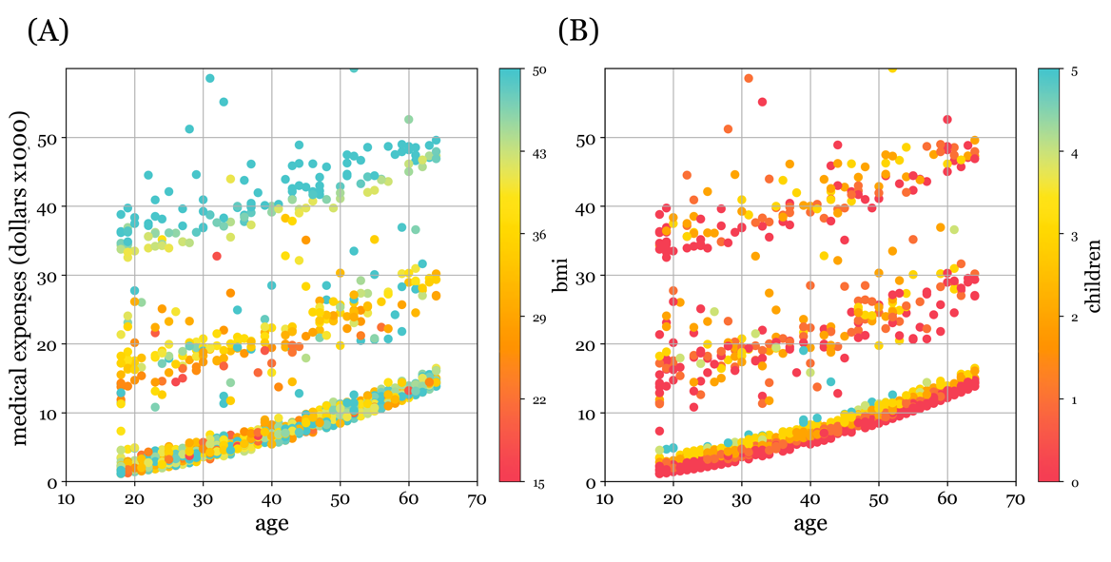
Figure 14.6 - Plotting medical expenses as a function of age, with individual data points color-coded according to a person's BMI (A) and the number of children they conceived (B). We can observe a faint trend toward higher medical expenses for higher BMIs. This should be an expected result: obesity is associated with many medical issues, such as diabetes type II and cardiovascular disease. It is perhaps odd that the effect is not stronger. In contrast, it doesn't seem the number of children has any clear influence on medical expenses of the birth parent. However, a closer look does reveal an effect, but only for a subset of our data, which can be seen more clearly in 14.7b. This is not all that surprising in the end, as childbearing in itself can be quite expensive.

In conclusion, the number of children you brought into this world, your BMI, and whether you are a smoker all influence your total amount of medical expenses. Geographic region and your sex assigned at birth do not. However, it does leave the three-band structure we observe in the data unexplained by each variable when considered in isolation. It is possible that this grouping effect is due to a variable not included in the data set, such as a difference in the type of insurance plan or some other demographic not listed. Alternatively, they could be an interaction effect between two or more variables. We can test the existence of interaction effects with the methods we outline in this chapter (to some extent). Therefore, we will return to this complete data set later. For now, we will start by explaining a single output of interest (medical expenses) from a single input variable (age).

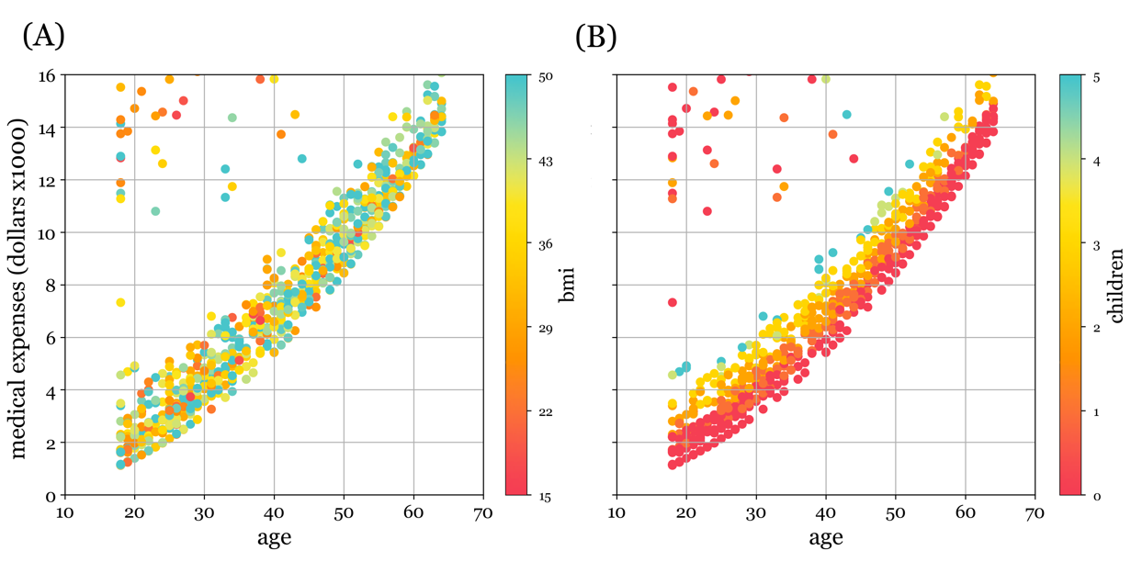
Figure 14.7 - Medical expense dataset, identical to Figure 14.6, but cropped to the lower band of data points only. Within this lower band, BMI doesn't seem to influence medical expenses (14.7b). In contrast, the effect of the number of children conceived on medical expenses appears to have been obscured in Figure 14.6, as individual data points overlapped too much to see a clear shift. By focusing only on those data points found in the lower band, when we do so, we do see that each additional child conceived shifts the total medical expenditure up by some significant amount.

14.7 - A subset of the data
Moving forward, we only use 20 random data points from the original data. We do this because we would like to work through the entire set of computations needed to fit a linear model without the need for many pages to detail this for thousands and thousands of data points. At the same time, we opt for selectively removing the data points that form the two smaller bands seen. We are aware of our cherry-picking tendencies, and please do not apply such filtering to any real data sets you might end up working with. We do it here, so our data has a pronounced and understandable relationship without having to resort to synthetic data. Finally, already at the raw data level, we divided medical expenses by 1000 dollars to bring it within a range that is like age. Thus, moving one unit up or down the y-axis equates to an increase or decrease of 1000 dollars.

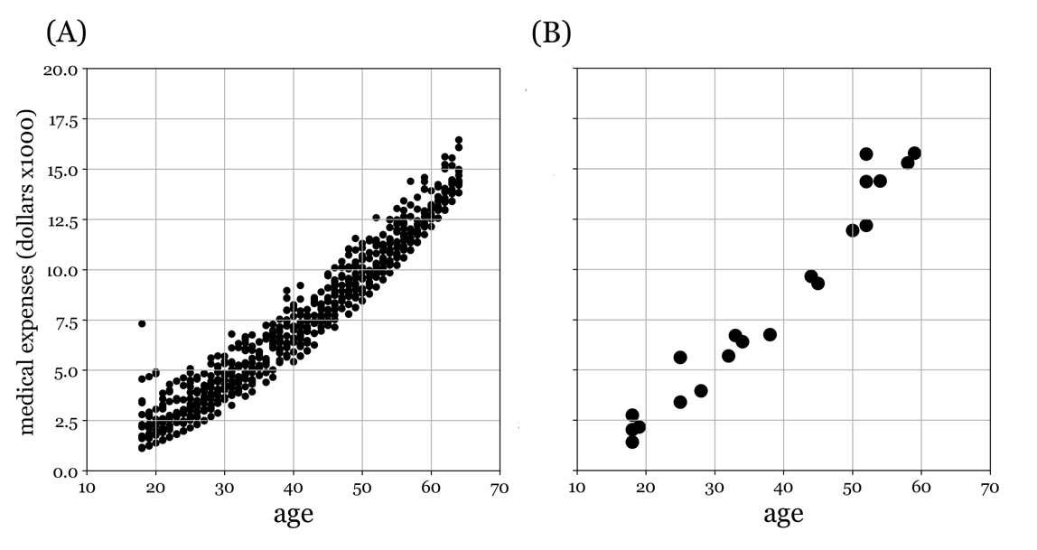
Figure 14.8 - (A) All remaining data points after removing the data points that make up the smaller bands. (B) We further subset the data in (A) to a random 20 points for use throughout this chapter.

